Practical No.01

Q.1] Display the dialog box using alert to display multiline text.

<!DOCTYPE html>
<html>
<head>
<title>Alert Multiline</title>
</head>
<body>

<script>
alert("Welcome to Client Side Scripting\nThis is a multiline alert box\nThank You!");
</script>

</body>
</html>

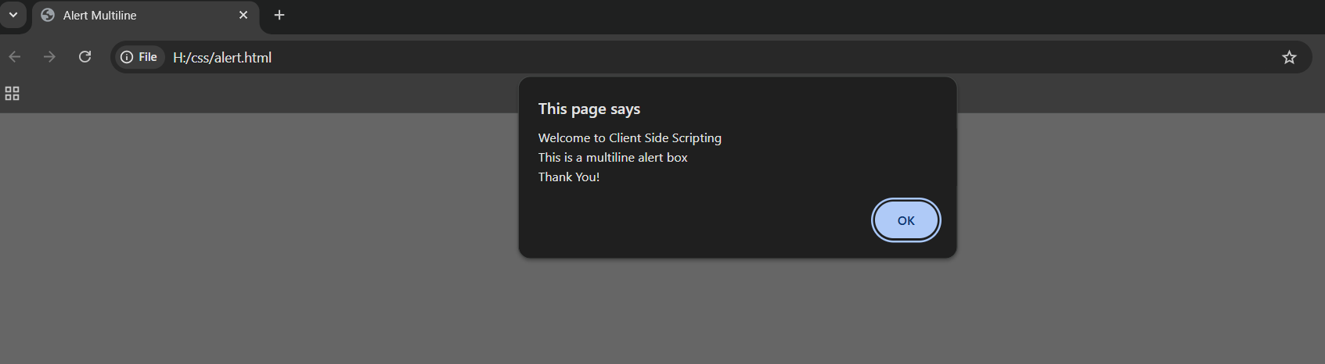
Output:-

Q.2] Display the text in document.write using HTML formatting tags

<!DOCTYPE html>
<html>
<head>
<title>HTML Formatting</title>
</head>
<body>

<script>
document.write("<b>Bold Text</b><br>");
document.write("<i>Italic Text</i><br>");
document.write("<u>Underlined Text</u><br>");
document.write("<h2>Heading Text</h2>");
document.write("<p>This is a <mark>highlighted</mark> paragraph.</p>");
</script>

</body>
</html>
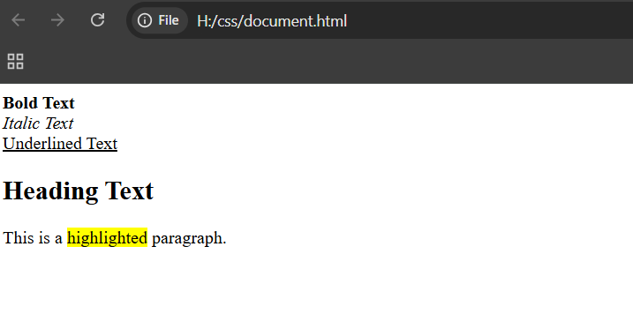

<!DOCTYPE html>
<html>
<head>
<title>Console Log Advanced</title>
</head>
<body>

<script>
console.log("Hello World");

var a = 10;
var b = 20;

console.log("Value of a:", a);
console.log("Value of b:", b);
console.log("Sum:", a + b);

console.log("Boolean Value:", true);
</script>

</body>
</html>

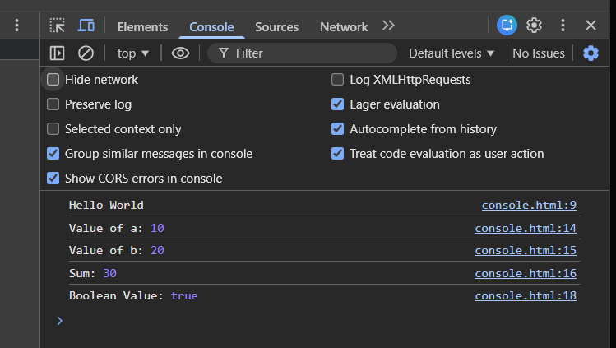
output :-

